The tradition of the Veneration of the Cross
dates back to the fourth-century. On Good Friday,
the Christians in Jerusalem would gather before a relic
of the true cross to kneel, bow, and kiss the cross in
remembrance of the Passion of Christ.
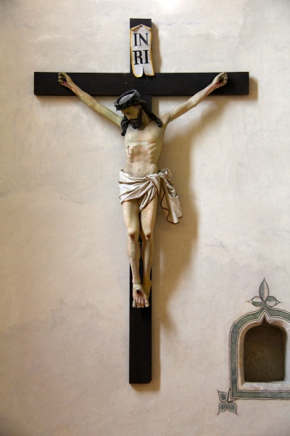
Today, most churches venerate the
cross during their Good Friday services.
This moving practice inspires great
prayer and meditation.
This year, due to the Coronavirus, many
of the Easter triduum Masses and services
are cancelled, including the veneration
of the cross on Good Friday.
So what do we do instead?
Here's your 3 step guide to
venerating the cross at home:
1) Put your most beautiful
crucifix in a place of honor.
You can place it on your mantle, a bookshelf,
or a table. Put some lit candles nearby and
prepare a place to kneel in front of it.

2) Kneel before the crucifix and
spend some time in prayer.
Thank Jesus for the gift of our salvation,
make an act of contrition, and say the
Prayer Before the Crucifix:
Behold, O kind and most sweet Jesus, I cast myself upon my knees in Thy sight, and with the most fervent desire of my soul, I pray and beseech Thee that Thou wouldst impress upon my heart lively sentiments of faith, hope and charity, with true contrition for my sins and a firm purpose of amendment; while with deep affection and grief of soul I ponder within myself and mentally contemplate Thy five wounds, having before my eyes the words which David, Thy prophet put on Thy lips concerning Thee: 'They have pierced My hands and My feet, they have numbered all My bones' (Psalm 21: 17,18).
Say an Our Father, Hail Mary, and Glory Be.

3) Kiss the crucifix.
Spend as much time as you'd like to in prayer
before the crucifix meditating on the Passion.
Whenever you'd like to, kiss Jesus' feet on your
crucifix and remember how truly loved we all are.

